**Assignment 4.3**

**Problem Statement:**

Write a program to implement wordcount using Pig.

Share the screenshots of the commands used with its associated output.

**dataset :** **wordsInTransport.txt**

bus,cycle,train

train,areoplane,motorbike

bus,boat,ship,cycle

1.lines = LOAD 'wordsInTransport.txt' AS (line:chararray);





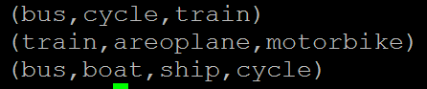

2. words = FOREACH lines GENERATE FLATTEN(TOKENIZE(line)) as word;





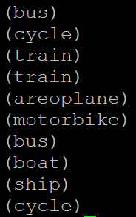

3.groupedWord = GROUP words BY word;





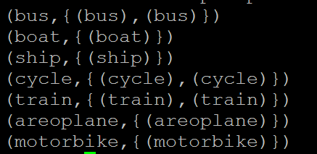

4. wordcount = FOREACH groupedWord GENERATE group, COUNT(words);

5. DUMP wordcount;



